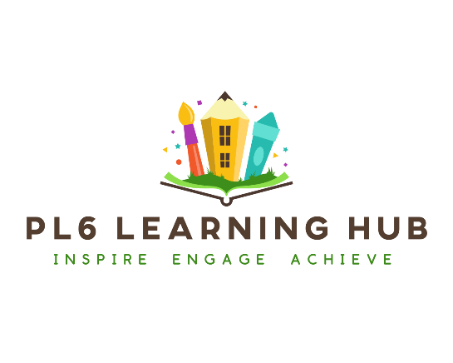

Confidentiality, Privacy and Data Retention Policy for Tutors

Any information given, either verbally or in writing, regarding your child or your family, will be treated as confidential. We are registered with the Information Commissioner’s Office (ICO) and we are aware of my responsibilities under General Data Protection Regulations (GDPR) and the Data Protection Act, 2018.
Information about your child will not be discussed with anyone else, except those named on initial agreements (namely parents/carers).
Exceptions can be made where written permission has been given to speak to a named individual either as a one-off or an ongoing basis e.g. a grandparent, school or another tutor your child might be working with.
If these permissions have been given, they can be withdrawn at any time and in that circumstance no further communication will be made.
PL6 Learning Hub will, however, divulge confidential information to the relevant authorities if there appears to be a safeguarding issue that potentially affects a child’s welfare and/or safety.
For more information about your full data rights, please take a look at the Information Commissioner's Office (ICO) website.

